Computer Networks

Lab Task #4

Saad Ahmad

20P-0051

**Task 1**

First add 2 PCs and 1 switch and 1 server.

Then configure the PCs by assigning the IP address, subnet mask and DNS server IP like:

**PC1:**

IP = 192.168.1.3

Subnet mask = 255.255.255.0

DNS server = 192.168.1.2

**PC2:**

IP = 192.168.1.4

Subnet mask = 255.255.255.0

DNS server = 192.168.1.2

**DNS Server:**

IP = 192.168.1.2

Subnet mask = 255.255.255.0

DNS server = 192.168.1.2

Now go to the services tab of the DNS server and select DNS from the menu and then add the PCs record in it.

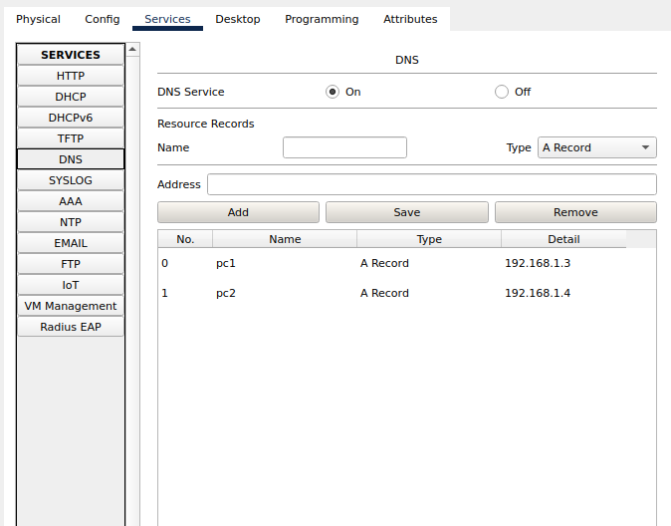

Remember to turn “**on**” the DNS service.

And now connect them all using the straight through cable.

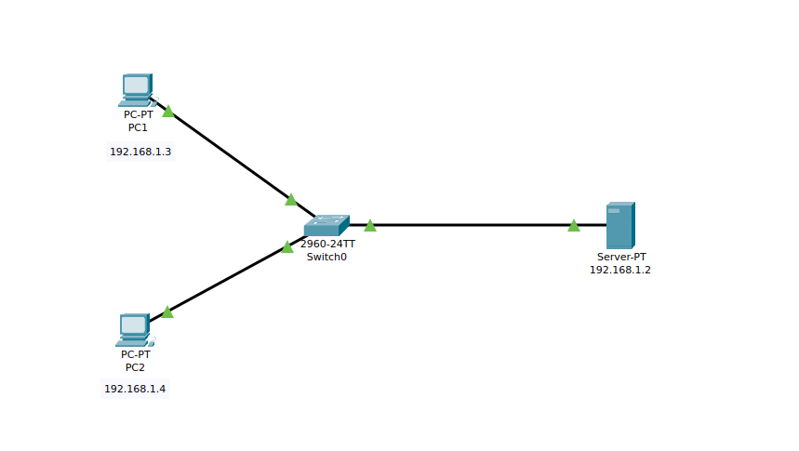

**Result:**

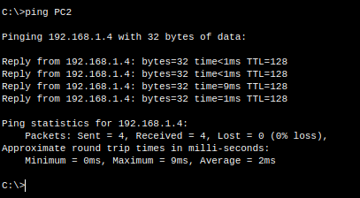

**Task 2**

First add 3 PCs and 1 switch and 1 router.

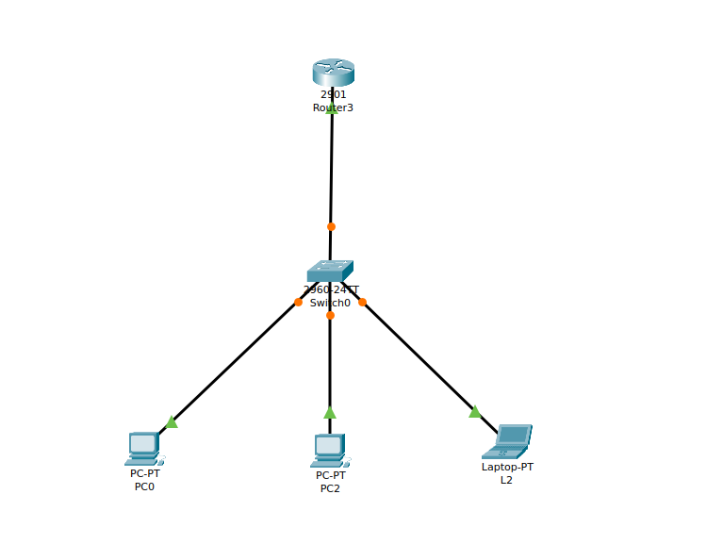Then configure the Router using CLI

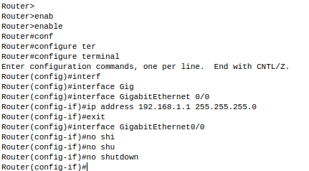

Now we will configure DHCP server on the Router.

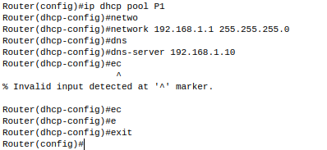

And now connect them all using the straight through cable.

Now go to every PC and on their IP, configuration tabs, enable DHCP. Every PC should be able to obtain an IP address, default gateway and DNS server.

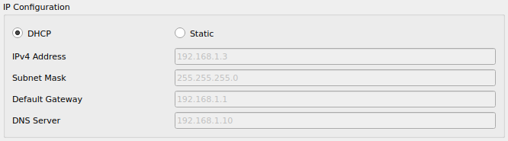

**Result:**



**Task 3**

First add 3 PCs and 1 switch and 1 server

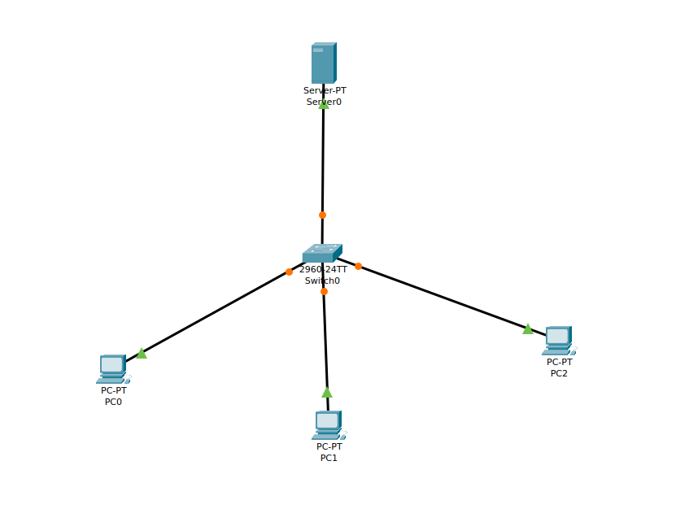

Now we will configure the server so for that assign the IP to the server and DNS server

**IP:**

192.168.1.2

**DNS:**

192.168.1.10

Now go to the service tab and select the DHCP from the menu. Then

proceed to define the DHCP network parameters as follows:

**Pool name**: serverPool

**Default Gateway**: 192.168.1.1

**DNS Server**: 192.168.1.10

**Start IP Address**: 192.168.1.0

**Subnet Mask**: 255.255.255.0

**Maximum Number of users**: 245

and now save it.

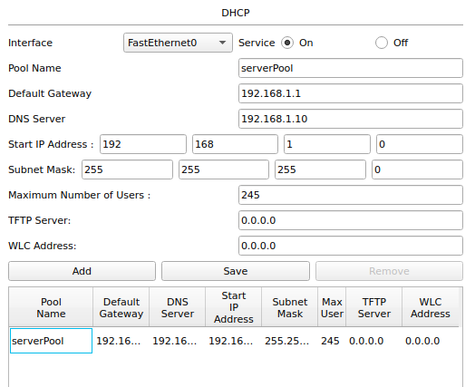

Now go to every PC and on their IP, configuration tabs, enable DHCP. Every PC should be able to obtain an IP address, default gateway and DNS server.

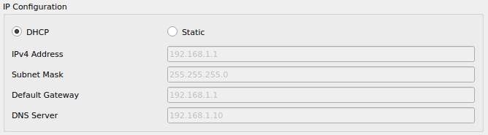

**Result:**

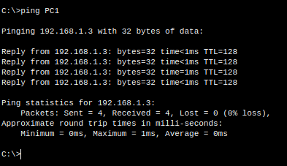

**Task 4**

First add 3 PCs and 1 switch and 1 router and 3 servers

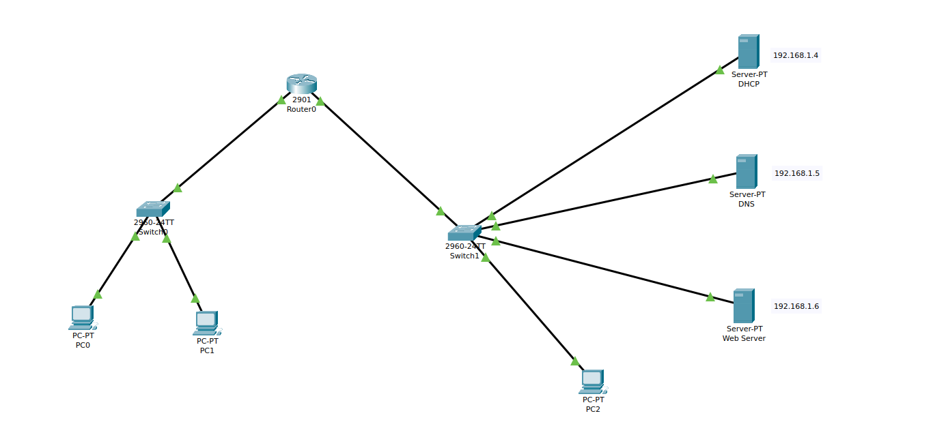

Now we will configure the servers first

**DHCP server:**

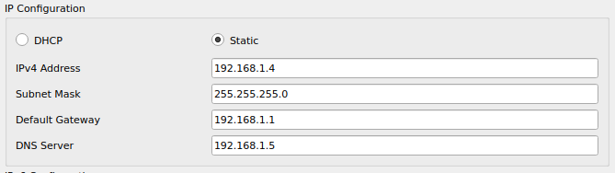

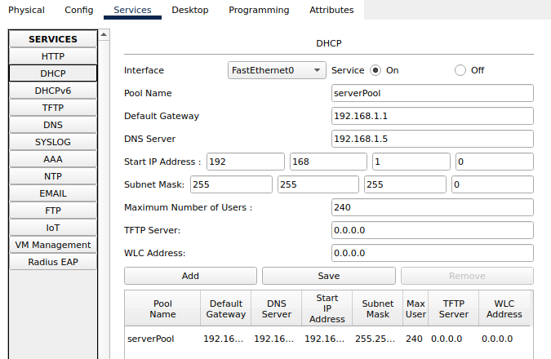

**DNS server:**

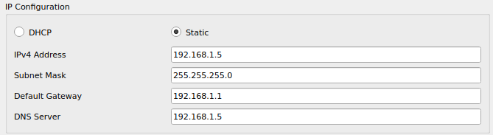

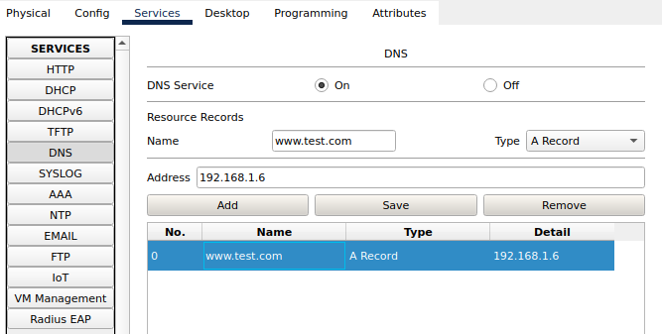

**Web server:**

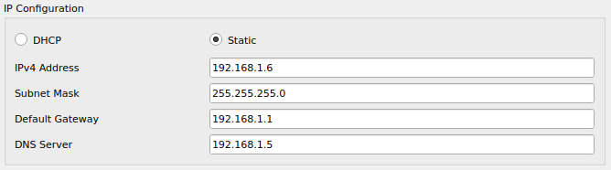

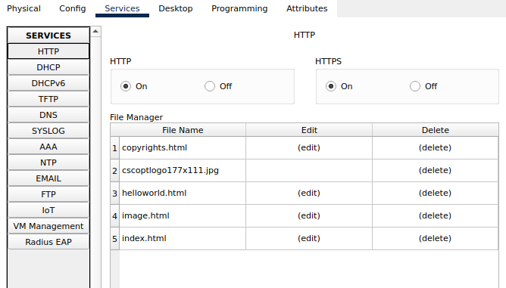

Now configure the Router

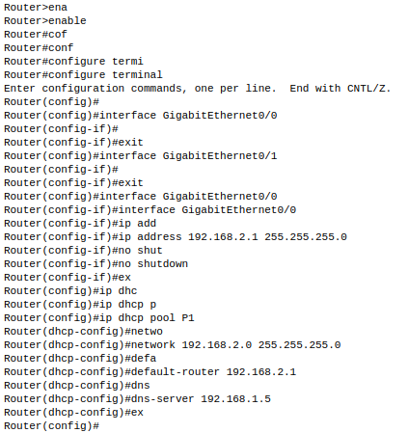

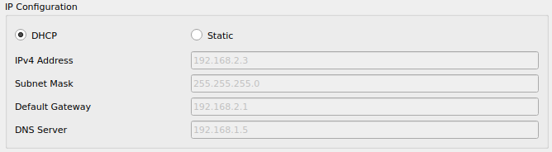Now go to every PC and on their IP, configuration tabs, enable DHCP. Every PC should be able to obtain an IP address, default gateway and DNS server.

**Result:**

